1. Product category: PLC (PROGRAMABLE LOGIC CONTROLLER)

PLC Company

DELTA

Model name:

[1. DVP-EH3 Series](https://www.deltaelectronicsindia.com/industrial-automation/programmable-logic-controller/dvp-eh3-series/" \o "DVP-EH3 Series)

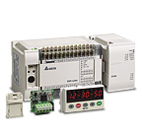

**DESCRIPTION**

The new generation DVP-EH3 PLC is the high-end model of the Delta DVP-E series.

It provides larger program capacity and data registers for more demanding and complex applications.

[2. DVP-EX Series](https://www.deltaelectronicsindia.com/industrial-automation/programmable-logic-controller/dvp-ex-series/" \o "DVP-EX Series)

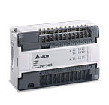

**DESCRIPTION**

The EX series is the analog MPU with the lowest cost. Apart from supporting digital input and output, the EX series has built-in multiple analog I/O channels and integrates a variety of communication protocol’s for constructing a complete control network. EX series is suitable for all kinds of small PLC applications.

[3. DVP-ES2/EX2 Series](https://www.deltaelectronicsindia.com/industrial-automation/programmable-logic-controller/dvp-es2-ex2-series/" \o "DVP-ES2/EX2 Series)

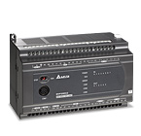

**DESCRIPTION**

* MPU points: 16 / 20 / 24 / 32 / 40 / 60
* Program capacity: 16k steps
* Built-in with 3 COM ports: 1 RS-232 port and 2 RS-485 ports, all are able to operate independently (Master/Slave)
* Max. I/O points: 256 input points + 16 output points, or 256 output points + 16 input points
* DVP-EX2 MPU is built in with 12-bit 4AD/2DA and offers analog/temperature modules of 14-bit resolution.
* Built-in with 8 high-speed input points (2 points for 100kHz, 6 points for 10kHz) and supports U/D, U/D Dir, A/B counting modes
* New motion control instructions: Close loop control, alignment mark, shield, immediate variable speed, S-Curve acceleration/deceleration

[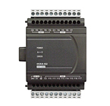](https://www.deltaelectronicsindia.com/industrial-automation/programmable-logic-controller/dvp-es2-ex2-series-expansion-module/" \o "DVP-ES2/EX2 Series Expansion Module)

[4. DVP-ES2/EX2 Series Expansion Module](https://www.deltaelectronicsindia.com/industrial-automation/programmable-logic-controller/dvp-es2-ex2-series-expansion-module/" \o "DVP-ES2/EX2 Series Expansion Module)

**DESCRIPTION**

* Digital modules (output/input/mix): 8,16, 32(AC power)
* Analog modules (output/input/mix): 4 channel, 6 channel inputs (14-bit)
* Temperature measurement modules: conversion time 200ms/channel, overall accuracy +/-0.6%, resolution RTD inputs Pt100 / Pt1000 / Ni100 / Ni1000, thermocouple inputs J, K, R, S, T, E, N type
* Resolver modules: distance 50M, resolution 12-bits, 500rpm, disconnection detection is supported

[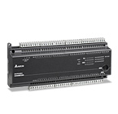](https://www.deltaelectronicsindia.com/industrial-automation/programmable-logic-controller/dvp-ec3-series/" \o "DVP-EC3 Series)

[5.DVP-EC3 Series](https://www.deltaelectronicsindia.com/industrial-automation/programmable-logic-controller/dvp-ec3-series/" \o "DVP-EC3 Series)

**DESCRIPTION**

EC3 series is the most economical solution for sequential control and communication monitoring and can operate independently, allowing the user to achieve stand-alone monitor, e.g. monitoring phototransistor coupler, proximity switch, optical sensor, indicator and illumination switch. Through serial ports, EC3 is able to connect to control devices such as PLC, frequency inverter and temperature controller, which can be said to be a programmable application solution that is cost-friendly and highly reliable.

6. ALL OTHER MODELS ARE ALSO AVIALABLE

**MITSUBISHI**

Model name:

**FX3U SERIES**

**DESCRIPTION**

|  |  |
| --- | --- |
| https://www.mitsubishielectric.com/fa/products/cnt/plc_fx/pmerit/contents/plc/images/fx3u.jpg | [https://www.mitsubishielectric.com/fa/products/cnt/plc_fx/pmerit/contents/plc/images/icon_io-block384.gif](https://www.mitsubishielectric.com/fa/products/cnt/plc_fx/pmerit/contents/plc/index.html#io-block384) [https://www.mitsubishielectric.com/fa/products/cnt/plc_fx/pmerit/contents/plc/images/icon_s-block.gif](https://www.mitsubishielectric.com/fa/products/cnt/plc_fx/pmerit/contents/plc/index.html#s-block) [https://www.mitsubishielectric.com/fa/products/cnt/plc_fx/pmerit/contents/plc/images/icon_board.gif](https://www.mitsubishielectric.com/fa/products/cnt/plc_fx/pmerit/contents/plc/index.html#board) [https://www.mitsubishielectric.com/fa/products/cnt/plc_fx/pmerit/contents/plc/images/icon_hc100.gif](https://www.mitsubishielectric.com/fa/products/cnt/plc_fx/pmerit/contents/plc/index.html#hc100) [https://www.mitsubishielectric.com/fa/products/cnt/plc_fx/pmerit/contents/plc/images/icon_positioning3.gif](https://www.mitsubishielectric.com/fa/products/cnt/plc_fx/pmerit/contents/plc/index.html#positioning3)  **Memory** 64,000 step RAM memory built-in. Flash memory cassette can also be mounted.  **Processing speed** Basic instruction: 0.065 μs/instruction (LD instruction) Application instruction: 0.642 to 100 μs/instruction **Device** Auxiliary relay: 7,680 pts Timer: 512 pts Counter: 235 pts Data register: 8,000 pts Extension register: 32,768 pts Extension file register (optional memory): 32,768 pts |

**Memory**  
64,000 step RAM memory built-in. Flash memory cassette can also be mounted.   
**Processing speed**  
Basic instruction: 0.065 μs/instruction (LD instruction) Application instruction: 0.642 to 100 μs/instruction  
**Device**  
Auxiliary relay: 7,680 pts Timer: 512 pts Counter: 235 pts Data register: 8,000 pts  
Extension register: 32,768 pts Extension file register (optional memory): 32,768 pts

**⇒ FX3S SERIES**

**DESCRIPTION**

|  |  |
| --- | --- |
| https://www.mitsubishielectric.com/fa/products/cnt/plc_fx/pmerit/contents/plc/images/fx3s.jpg | [https://www.mitsubishielectric.com/fa/products/cnt/plc_fx/pmerit/contents/plc/images/icon_board.gif](https://www.mitsubishielectric.com/fa/products/cnt/plc_fx/pmerit/contents/plc/index.html#board) [https://www.mitsubishielectric.com/fa/products/cnt/plc_fx/pmerit/contents/plc/images/icon_s-block.gif](https://www.mitsubishielectric.com/fa/products/cnt/plc_fx/pmerit/contents/plc/index.html#s-block) [https://www.mitsubishielectric.com/fa/products/cnt/plc_fx/pmerit/contents/plc/images/icon_hc60-10_2.gif](https://www.mitsubishielectric.com/fa/products/cnt/plc_fx/pmerit/contents/plc/index.html#hc60-10) [https://www.mitsubishielectric.com/fa/products/cnt/plc_fx/pmerit/contents/plc/images/icon_positioning2.gif](https://www.mitsubishielectric.com/fa/products/cnt/plc_fx/pmerit/contents/plc/index.html#positioning2) [https://www.mitsubishielectric.com/fa/products/cnt/plc_fx/pmerit/contents/plc/images/icon_ad.gif](https://www.mitsubishielectric.com/fa/products/cnt/plc_fx/pmerit/contents/plc/index.html#ad)  **Memory** 16,000 step EEPROM memory built-in. Battery-free and maintenance-free. (Program capacity is 4,000 steps) **Processing speed** Basic instruction: 0.21 μs/instruction Application instruction: 0.5 to 100μs/instruction **Device** Auxiliary relay: 1,536 pts Timer: 138 pts Counter: 67 pts Data register: 3,000 pts |

**Memory**  
16,000 step EEPROM memory built-in. Battery-free and maintenance-free.  
(Program capacity is 4,000 steps)  
**Processing speed**  
Basic instruction: 0.21 μs/instruction  
Application instruction: 0.5 to 100μs/instruction  
**Device**  
Auxiliary relay: 1,536 pts Timer: 138 pts Counter: 67 pts Data register: 3,000 pts

**⇒ FX3G SERIES**

**DESCRIPTION**

|  |  |
| --- | --- |
| https://www.mitsubishielectric.com/fa/products/cnt/plc_fx/pmerit/contents/plc/images/fx3g.jpg | [https://www.mitsubishielectric.com/fa/products/cnt/plc_fx/pmerit/contents/plc/images/icon_io-block256.gif](https://www.mitsubishielectric.com/fa/products/cnt/plc_fx/pmerit/contents/plc/index.html#io-block256) [https://www.mitsubishielectric.com/fa/products/cnt/plc_fx/pmerit/contents/plc/images/icon_s-block.gif](https://www.mitsubishielectric.com/fa/products/cnt/plc_fx/pmerit/contents/plc/index.html#s-block) [https://www.mitsubishielectric.com/fa/products/cnt/plc_fx/pmerit/contents/plc/images/icon_board-2.gif](https://www.mitsubishielectric.com/fa/products/cnt/plc_fx/pmerit/contents/plc/index.html#board) [https://www.mitsubishielectric.com/fa/products/cnt/plc_fx/pmerit/contents/plc/images/icon_hc60-10.gif](https://www.mitsubishielectric.com/fa/products/cnt/plc_fx/pmerit/contents/plc/index.html#hc60-10) [https://www.mitsubishielectric.com/fa/products/cnt/plc_fx/pmerit/contents/plc/images/icon_positioning3-2.gif](https://www.mitsubishielectric.com/fa/products/cnt/plc_fx/pmerit/contents/plc/index.html#positioning3)  **Memory** 32,000 step EEPROM memory built-in. Battery-free and maintenance-free. **Processing speed** Basic instruction: 0.21μs/instruction (in standard mode) 0.42μs/instruction (in extension mode) Application instruction: 0.5 to 100 μs/instruction (in standard mode) 1.2 to 100 μs/instruction (in extension mode) **Device** Auxiliary relay: 7,680 pts Timer: 320 pts Counter: 235 pts Data register: 8,000 pts Extension register: 24,000 pts Extension file register: 24,000 pts |

**Memory**  
32,000 step EEPROM memory built-in. Battery-free and maintenance-free.  
**Processing speed**  
Basic instruction: 0.21μs/instruction (in standard mode) 0.42μs/instruction (in extension mode)  
Application instruction: 0.5 to 100 μs/instruction (in standard mode) 1.2 to 100 μs/instruction (in extension mode)  
**Device**  
Auxiliary relay: 7,680 pts Timer: 320 pts Counter: 235 pts Data register: 8,000 pts  
Extension register: 24,000 pts Extension file register: 24,000 pts

**⇒ Q Series**

**DESCRIPTION**

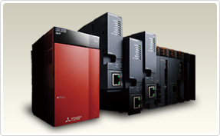

With its nano-order speed basic command processes, the next generation MELSEC-Q Series dramatically improves system and machine performance.

As equipment and manufacturing facilities continue to evolve on a daily basis, the series enables high-speed, high-accuracy and large volume data processing and machine control.

**SIEMENS**

Model name:

**1. SIEMENS S7 300**

### Description

The SIMATIC S7-300 universal controller saves on installation space and features a modular design.A wide range of modules can be used to expand the system centrally or to create decentralized structures according to the task at hand, and facilitates a cost-effective stock of spare parts. With its impressive array of innovations, the SIMATIC S7-300 universal controller is an integrated system that will save you additional investment and maintenance costs.

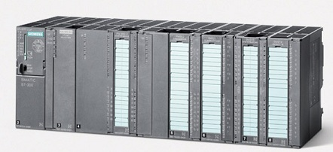

1. **Simentic s7-1200**

**Descripton**

As an interface to the machine or plant, a wide variety of signal modules for input and output as well as technology modules for special technological functions, such as counting, and communications modules are available both centrally or decentrally. The SIMATIC S7-1200 is approved for protection class IP20 and is intended for installation in a control cabinet.

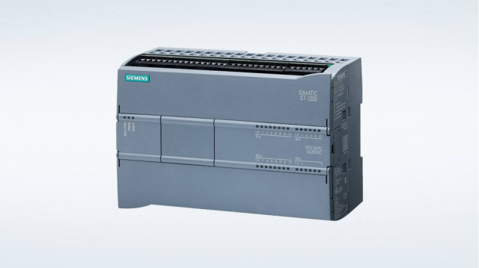

1. ALL OTHER SIMENTIC S7 MODELS ARE ALSO AVIALABLE

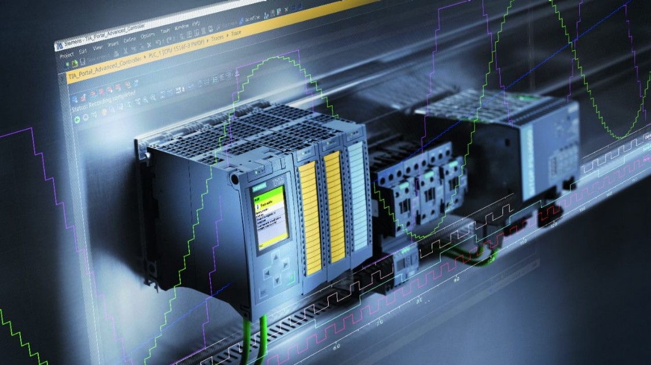

OMRON

MODEL NAME:

1.OMRON- CP1E

**DESCRIPTION**

The CP1E provide high cost performance to further reduce costs by allowing you to select the optimal CPU Unit from the E[][]S-type Basic Models or N/[][]S(1)-type Application Models.

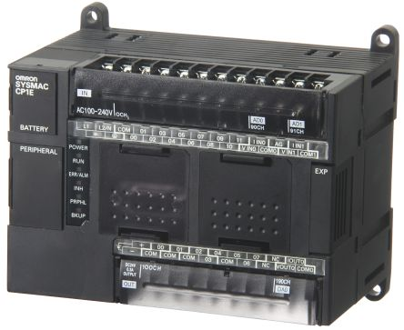

**2. OMRON-CP1L**

**DESCRIPTION**

 "CP1L-EM" and "CP1L-EL" have complete with a Ethernet port.

• Pulse output for two axes. Advanced power for high-precision positioning control.

• High-speed Counters. Single-phase for four axes.

• Six interrupt inputs are built in. Faster processing of instructions speeds up the entire system.

• Serial Communications. Two ports. Select Option Boards for either RS-232C or RS-485 communications.

• "CP1L-M" and "CP1L-L" have a peripheral USB port.

• The Structured Text (ST) Language. Makes math operations even easier.

• Can be used for the CP1W series Unit. The extendibility of it is preeminently good.

• LCD displays and settings. Enabled using Option Board.

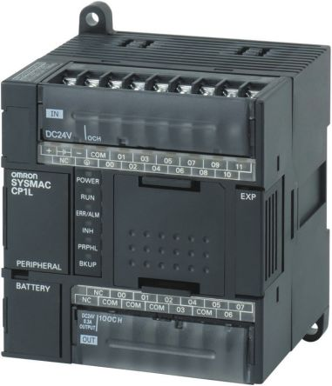

1. **OMRON-CP1H**

**DESCRIPTION**

• Pulse output for 4 axes. Advanced power for high-precision positioning control.

• High-speed counters. Differential phases for 4 axes. Easily handles multi-axis control with a single unit.

• Eight interrupt inputs are built in. Faster processing of approximately 500 instructions speeds up the entire system.

• Serial communications. Two ports. Select Option Boards for either RS-232C or RS-485 communications.

• Ethernet Communications. Enabled by using an Option Board. Two ports can be used as an Ethernet port to perform. Ethernet communications between the CP1H and a host computer.

• Built-in Analog I/O. XA CPU Units provide 4 input words and 2 output words.

• USB Peripheral Port. Another standard feature.

• The structured text (ST) language. Makes math operations even easier.

• Can be used for the CP1W series and CJ series Unit. The extendibility of it is preeminently good.

• LCD displays and settings. Enabled using Option Board.

